A000-Afr-Nigeria-Edo Court of Benin-Plaque of Mounted Oba and Attendants-Bronze-16th c

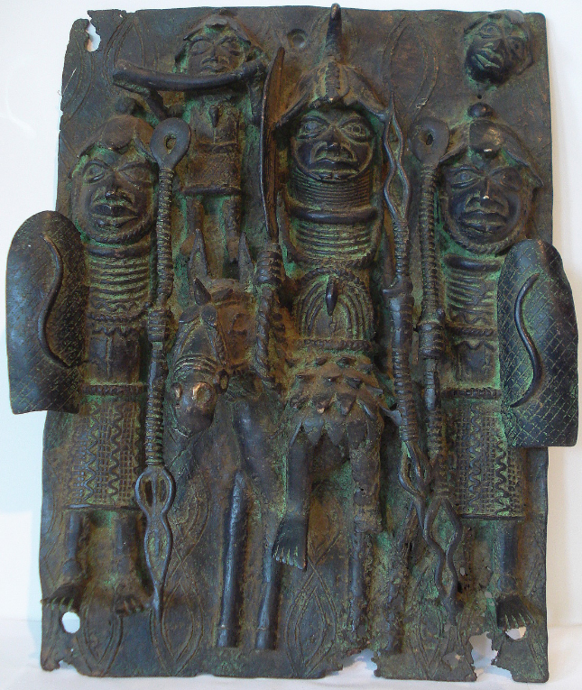

Afr-Nigeria-Edo Court of Benin-Plaque of Mounted Oba and Attendants-Bronze-16th c

Case No.: 6

**Accession No.**

**Formal Label:** Afr-Nigeria-Edo Court of Benin-Plaque of Mounted Oba and Attendants-Bronze-16th c

**Display Description:**

This bronze equestrian plaque may have once adorned the wooden pillars of the regal *Oba's* palace in Benin city (now Nigeria) probably dating to the 16th-17th centuries CE. It was cast using the lost wax process so that each cast was made from a mold that was broken following casting, and in this respect the plaque is unique.

The plaque represents a decapitation scene with a chief (*Oba*) mounted side-saddle on his royal steed appropriately caparisoned. The *Oba* is holding in his right hand a broad leaf-shaped ceremonial sword (*Eben*) at a right angle to the viewer suggesting that he is about to use it. In his left hand he is holding an openwork spear. He wears the royal heavily beaded coral choker and a beaded agate and coral cuirass. He is flanked by two royal attendants also with heavily beaded coral chokers and serpentine breast ornaments. Each is holding a cross-hatched shield (probably leather over a wicker frame) with a serpentine motif bilaterally mirrored in each of the shields. Their spears also have an openwork design. Above and to the viewer's left is a ceremonial trumpeter, and to the viewer's right is a disembodied head. The scene with both the trumpeter and the disembodied head suggests that it is commemorative of a decapitation *Ugieivie* ceremony in which the *Oba's* coral beads (*ivie)* and other regalia were to be displayed by the *Iwebo* palace association in the *Oba's* *Ewauare* shrine in preparation for a sacrifice to be made over them (Bradbury 1957: 59). The two flanking warriors display abstract-design textile breechcloths with a serpentine design similar to that on their shields, probably an apotropaic or protective motif. Another apotropaic motif just barely visible is a series of openwork spears that are emblazoned into the background of the entire plaque.

Benin brass plaques are principally concerned with praising the *Oba*. They were nailed to the walls of his palace - rather in the same way as tapestries in a European context - and they allowed the visitor to admire both the achievements of the ruler and the wealth of the kingdom. The overall effect was enthusiastically described in detail by an early Dutch visitor:

"The king's court is square. It is divided into many magnificent palaces, houses and apartments of the courtiers, and comprises beautiful and long square galleries, about as large as the Exchange at Amsterdam. From top to bottom covered with cast copper, on which are engraved the pictures of their war exploits and battles, and are kept very clean" (from BBC 2012).

**LC Classification:**

**Date or Time Horizon:**

**Geographical Area:**

**Map:**

**GPS coordinates:**

**Cultural Affiliation:**

**Media:**

**Dimensions:** Height 15in.     Width 11.25.

**Weight:**

**Condition:**

**Provenance:**

**Discussion:**

The Nigerian-born sculptor, Wole Soyinka, noted the amount of coral rings around the necks of the Oba and his attendants:

"The Oba has a certain amount of rings on his neck, and even when you see contemporary pictures of the oba, he has more coral rings than anybody else, and his chest piece has more coral on it. You know, the remarkable thing about Nigeria is that all the coral and things don't actually come from our coast, they come from Portugal, and places like that. So all of that conversation has always been very important to me, you know we have things that are supposed to be totally traditional, yet they're traditional through trade" (from BBC 2012).

**References:**

BBC. 2012. A History of the world, episode 77- Benin plaque: the oba with Europeans. http://www.bbc.co.uk/ahistoryoftheworld/about/transcripts/episode77/

Bradbury, R. E. 1957. *The Benin kingdom and the Edo-speaking peoples of south-western Nigeria*. Ethnographic Survey of Africa, Western Africa: part XIII. London: International African Institute.

Forman, W. and B, and Dark, Philip. 1960. *Benin art*. London: Paul Hamlyn.

**Appendix:**  
 